Garth Adcock

IT-373

System Concepts

VM Platform: Cloud 9 IDE

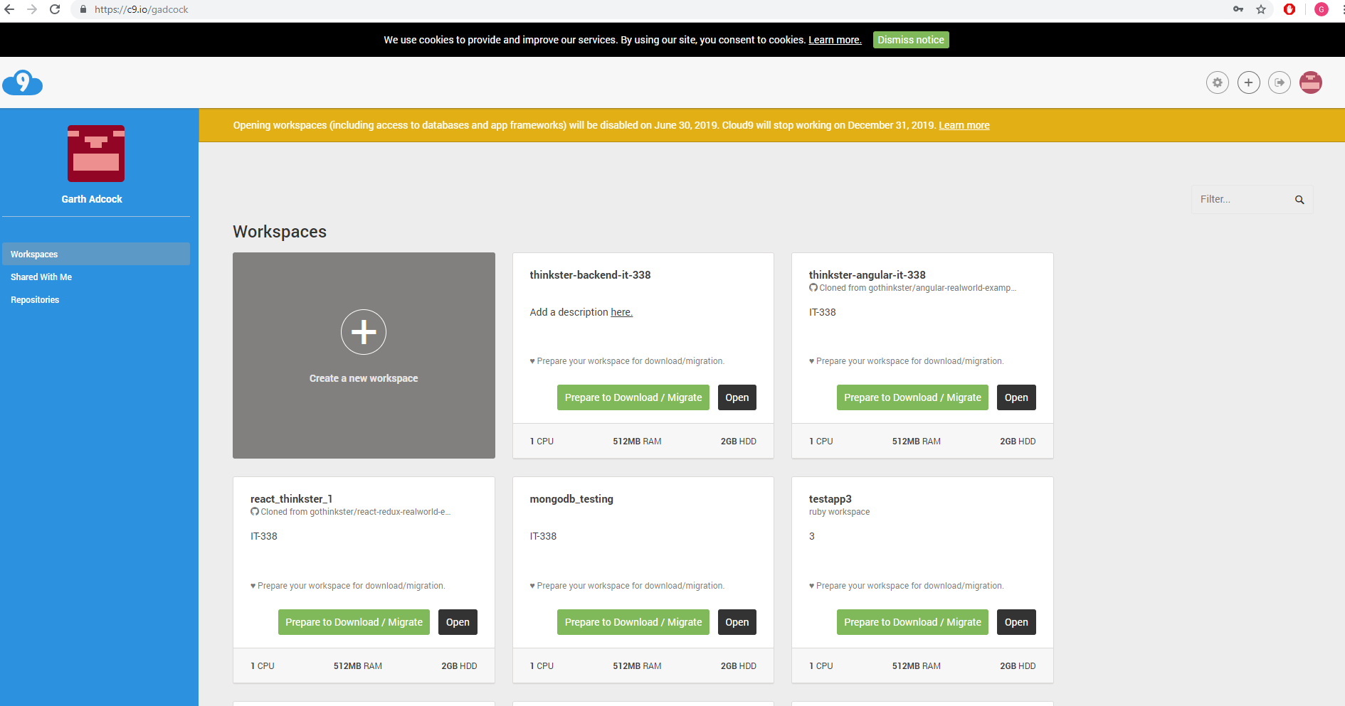

Above is the dashboard of the Cloud9 IDE. The IDE I have chosen to utilize for this course. Here, one can view their created projects and manage their account.

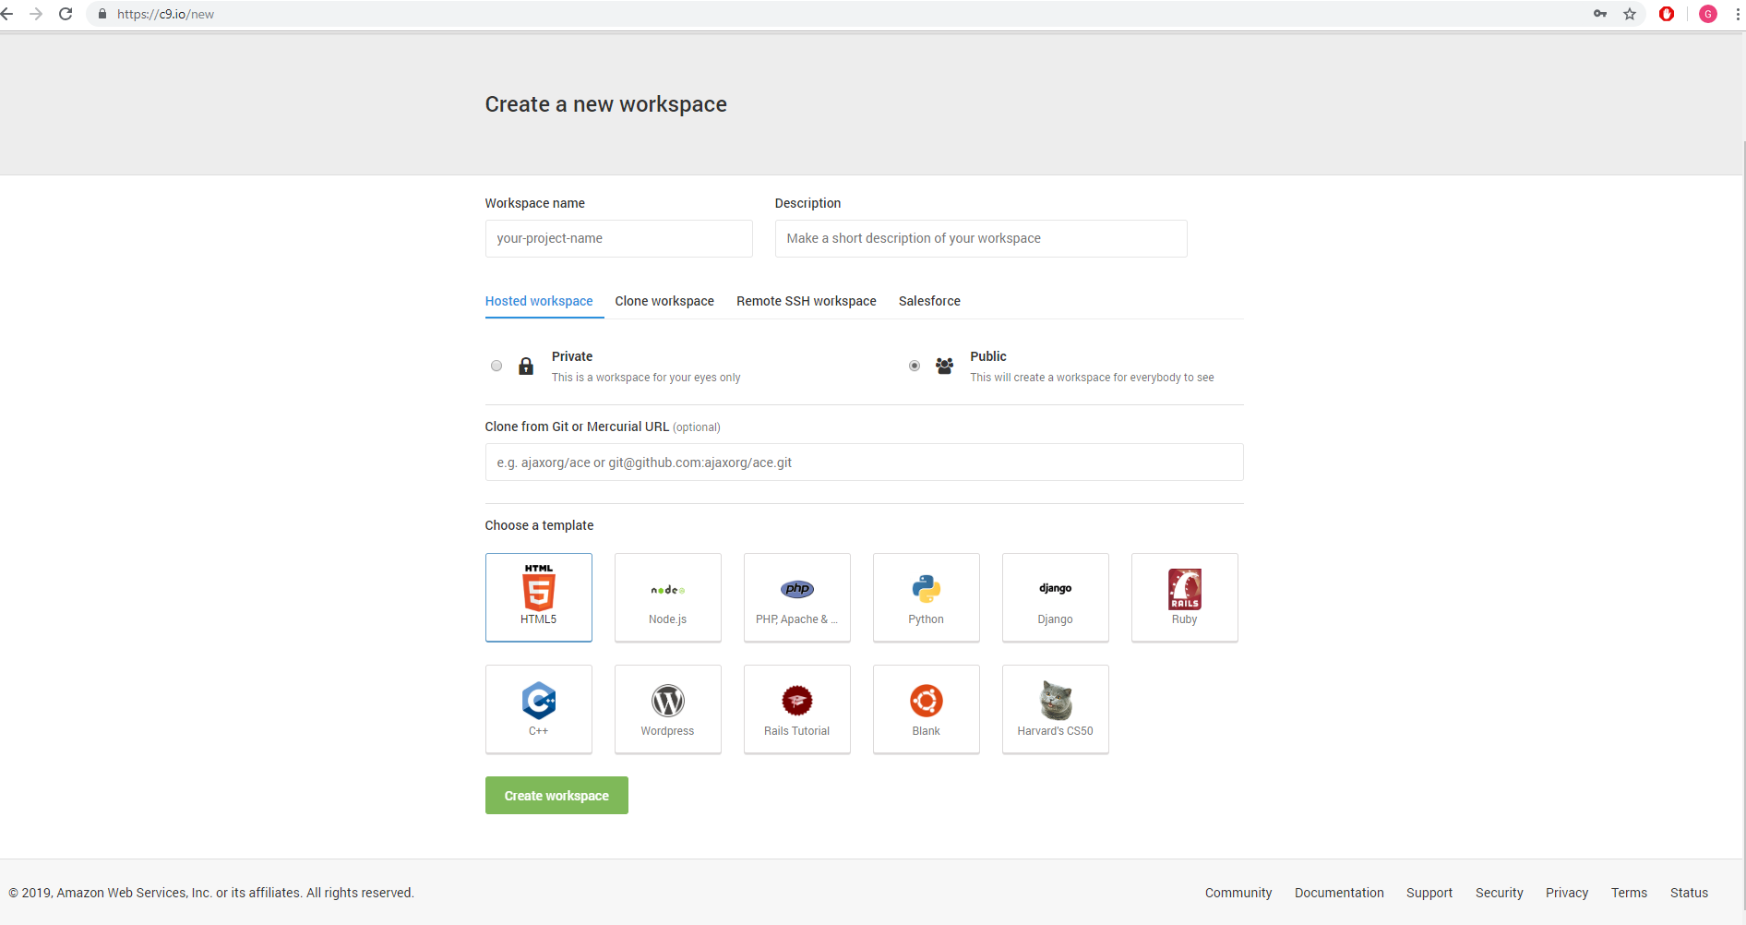

The screenshot above showcases the making of a new project, and the various types available. For this I have selected blank Ubuntu Linux to use.

Below is a screenshot of the newly created project, featuring the file structure on the left-hand side, the immediate window/console on the bottom, and view of current file in the center.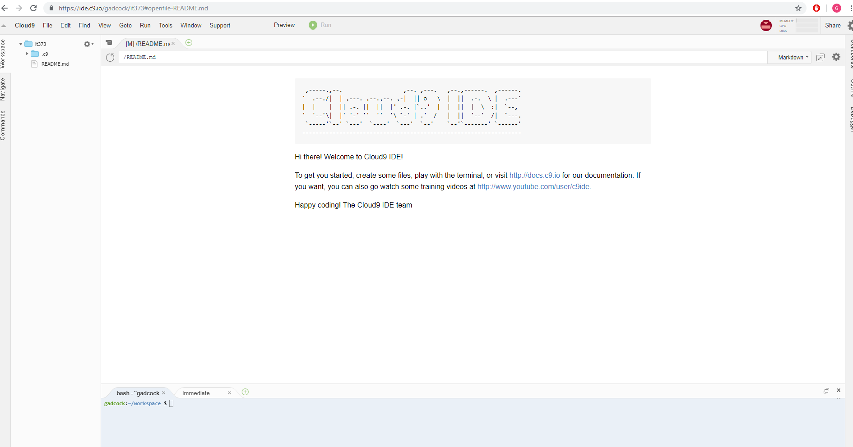

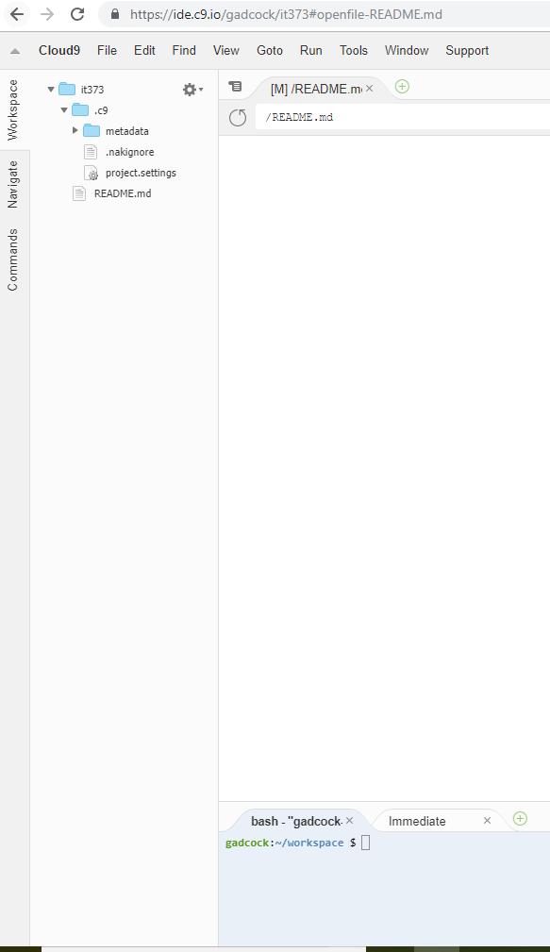The screenshot below showcases the file structure to the left-hand side where the user and create, view, delete, and update their files.

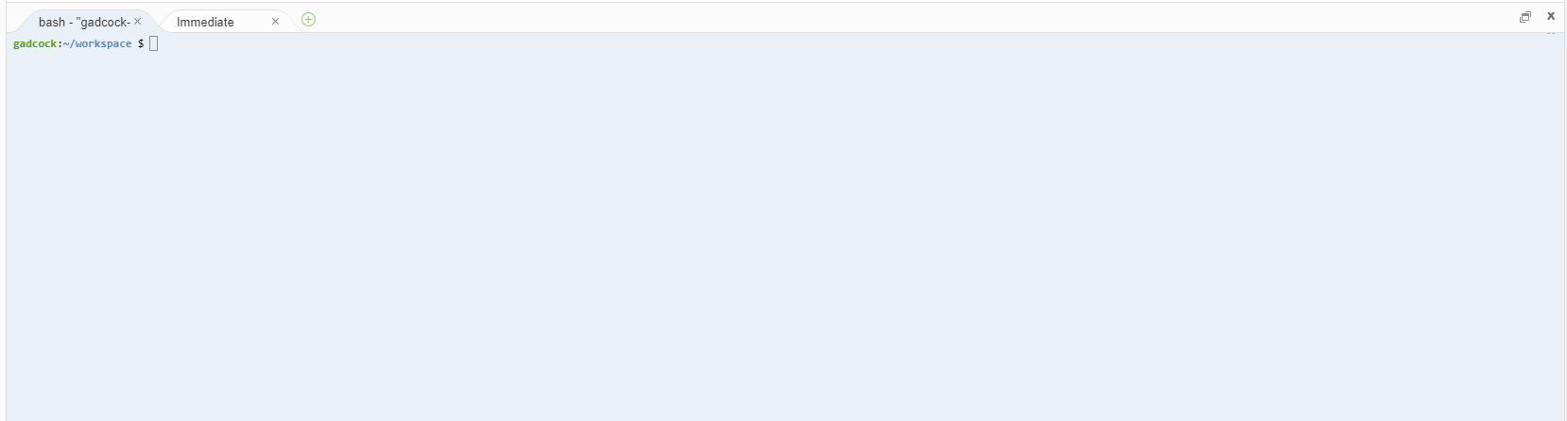

The above screenshot displays the console where the user can enter commands on the Ubuntu Linux machine.